CptS 484: Software Requirements
WRS Evolution
Requirements Elicitation

Emily Porter
Joshua Allard
Noah Schmalenberger
Nicole Fuller
Alena Watts
Lance Tieng

10/12/2025

0
Revision History 3
[1] Introduction 3
1.1. Purpose of the System 3
1.2. Scope of the System 3
1.3. Objectives and Success Criteria 3
1.4. Definitions, Acronyms, and Abbreviations 3
1.5. Overview 3
[2] Issues with the Preliminary Definition Given 3
2.1. Domain, Stakeholders, Functional, and Non-Functional Objectives 3
2.2. Functional Requirements 10
2.3. Non-Functional Requirements 16
[3] WRS 23
3.1. W 23
3.1.1. Problem 23
3.1.2. Goals 23
3.1.3. Improved Understanding of Domain, Stakeholders, Functional, and Non-Functional Objectives 23
3.1.3.1. Domain: Disabilities 23
3.1.3.2. Domain: Activities 25
3.1.3.3. Stakeholders 25
3.1.3.4. Functional Objectives 26
3.1.3.5. Non-Functional Objectives 26
3.2. RS 27
3.2.1. Functional RS—Improved Understanding of Software System Requirements: Functional Requirements 27
3.2.2. Non-Functional RS—Improved Understanding of Software System Requirements: Non-Functional Requirements 29
[4] Preliminary Prototype 33
[5] Prototype Interface Mock-ups 33
[6] User Manual 33
[7] Traceability 33
[8] References 33
[9] Appendix I: Process Details 33
9.1. Phase 1 Roles 33
9.2. Meetings 33
9.3. Activities 33
[10] Index 33

Revision History
Date | Version | Changes | Editor
9/17/25 | 1.0 | Initial Draft | Joshua Allard, Emily Porter, Noah Schmalenberger
9/18/25 | 1.1 | Updated Functional Requirements | Joshua Allard
￼10/1/25 | ￼1.2 | ￼Updated Preliminary Domain and Domain Issues | ￼Nicole Fuller
10/1/25 | 1.3 | Updated Preliminary Stakeholder and Stakeholder Issues | Emily Porter
10/1/25 | 1.4 | Updated section 3.3 | Noah Schmaleberger
10/7/25 | 1.5 | Updated section 4.1 | Noah Schmaleberger
10/7/25 | 1.6 | Updated Section 2.4 | Alena Watts
10/8/25 | 1.7 | Updated Section 3.4 | Alena Watts
10/11/25 | 1.8 | Updated Traceability Matrix | Joshua Allard
10/11/25 | 1.9 | Updated Prototype Interface Mockups and User Manual | Nicole Fuller
￼10/11/25 | ￼1.10 | ￼Added section 1 | ￼Emily Porter
￼10/12/25 | ￼1.11 | ￼Updated Meeting schedule | ￼Alena Watts

Introduction

Purpose
The purpose of this project is to develop a smartphone application that assists visually impaired people with indoor navigation. Theia, the smartphone application, will aid users in navigating from place to place within an indoor environment. Each building has their own layout and their own obstacles. Theia will adapt to obstacles (furniture, strange layouts, etc.) to ensure the safe transportation of its users. Additionally, to ensure that each user receives the most beneficial experience, Theia is configurable to each visually impaired user’s needs. Ultimately, Theia’s purpose is to provide a safe and easy way for visually impaired people to navigate indoor environments.

Scope
The Theia application will be a cross-platform mobile application, accessible on multiple types of smartphones, whether that be Apple, Samsung, or Android. It will use existing hardware components of a smartphone, such as cameras, microphones, and speakers.
Using sensor data and spatial mapping, Theia will be able to assist its users in traversing whatever indoor environment the user is in. It will provide step-by-step instructions to effectively and safely direct users to their goal destination. This includes moving to a different floor, between buildings, and between rooms. From sensor data analysis, if there is an obstacle, Theia will be able to detect it and help users avoid or navigate through it.

Objectives and Success Criteria
The objectives and success criteria that the:
- Adaptable to any indoor environment
- Communicate instructions clearly and effectively to visually impaired user
- Successfully direct visually impaired user to goal destination
- Works on multiple types of smartphones
- Option to contact emergency services if needed
- Be easy to use
- Be configurable to each user's disability

Definitions, Acronyms, and Abbreviations
Term | Definition
Visually impaired person | Any person with a visual disability, including being blind.
WRS | Website Requirements Specification

Overview
In Section 2, the preliminary domain, stakeholders, functional requirements, and nonfunctional requirements were identified. From there, in section 3, the issues with the domain, stakeholders, functional requirements, and nonfunction requirements were found and described. Each issue had different options for paths forward, and the chosen option was picked.
Section 4 is split into a couple different parts for W and RS. The W section covers the type of problems that the application will cover and the corresponding goals. From there, in Section 4.1.3, improved understanding of the domain, stakeholders, functional objectives, and non-functional objects are recognized and described. In the RS part of the WRS, the types of requirements and their implementations are discussed.
Section 5 discusses the preliminary prototype and in Section 6 prototype interface mock-ups are provided. In Section 7, the user manual is implemented. Within Section 8, the traceability for functional and non-function requirements can be found.

Preliminary Definition

Preliminary Domain
PD_ID | Preliminary Domain Description
PD1 | Indoor navigation complexity
PD2 | Obstacle detection ambiguity

Preliminary Stakeholder
PD_ID | Preliminary Stakeholder Description
PS1 | Blind or visually impaired people who need to navigate indoors
PS2 | Caretaker, someone who aides the blind person in configuring the application
PS3 | Accessibility department staff who may upload indoor maps/layouts

Preliminary Functional Requirements
P FR_ ID | Preliminary FR Description
PFR1 | Accept a location from the user to navigate to using voice commands or another form of user interface
PFR2 | User can confirm destinations that have been suggested or selected by the user
PFR3 | Figure out multiple routes to the users confirmed destination and inform them of the options as well as describe each route including time, distance, and potential obstacles.
PFR4 | While navigating inform the user of their distance to the next direction
PFR5 | While navigating, when reaching a stop or turn inform the user and tell them where to go
PFR6 | Detect obstacles using sensors and tell user how to avoid them
PFR7 | Place emergency calls and messages when a fall occurs or the system is lost
PFR8 | Predict what the user's actions would be in advance using their location habits and schedule, suggesting their next destination and accepting the user's choice.
PFR9 | User can create new emergency contacts for the system to use, including setting priority for their contacts
PFR10 | User can customize settings such as volume, route update frequency, and language.

Preliminary Non-Functional Requirements
PNFR_ ID | Preliminary NFR Description
PNFR1 | The system shall be secure
PNFR2 | The system shall be usable
PNFR3 | Generating desired sentences and representing them pictorially as well as associating with a sound/voice.
PNFR4 | The system has a response time of about 2-3 seconds for user input under normal operating commands/conditions
PNFR5 | System should be available daily, allowing for multi-user access, ensuring especially high availability during navigation and emergency situations
PNFR6 | The system should securely save and encrypt users' personal data, such as their location history and username/email address. The system must also follow privacy protection rules and regulations.
PNFR7 | The system should support the switching of multiple languages via settings, with clear voice communication and understanding of voice prompts for every language
PNFR8 | The system should be reliable in all areas whether there is low lighting, crowds, or loud noise conditions, should also support when the user reports new obstacles in real time
PNFR9 | The system should be able to understand most, if not all, commands given by the user, as long as they that fall under the systems recognized keywords
PNFR10 | System should be able to support the modification of the visual settings, such as text size, button size, and having a simple and standard menu

Issues with the Preliminary Definition Given

Domain Issues
Domain Issue ID | Domain Issue Description
DI1 | PD_ID | PD1. Indoor navigation complexity
DI1 | - Each building has a different floor plan with varying levels of square footage, rooms, and floors.
DI1 | Option 1 | Work with schools/building managers to get a digital floorplan and upload the complete map of the building, so that the app can integrate it
DI1 | Option 2 | Allow a caretaker to add and update map data
DI1 | Option 3 | Sensors will alert user of walls and give basic directions that would mostly just prevent user from running into anything
DI1 | Choice | Option 1
DI1 | Rationale | Option one provides the most complete domain knowledge of the listed options. It is the most simple and usable option for getting a building’s schematic.
Satisfied by

Domain Issue ID | Domain Issue Description
DI2 | PD_ID | PD2. Obstacle detection ambiguity
DI2 | - The project specification mentions detecting obstacles, but it is unclear what types of objects the app should detect  - Different obstacles may have priority for avoidance
DI2 | Option 1 | Define objects into different categories such as static obstacles, temporary obstacles, and dynamic obstacles. Static obstacles would include walls, etc., temporary obstacles would include chairs, etc., and dynamic obstacles would include people, etc. Depending on the object type, the app would alert the user of possible detours whether it’s to take a different route or take some amount of steps to the side to avoid, or alert user to stop for a moment in the case of a moving object
DI2 | Option 2 | Use the phone’s camera to detect obstacles in the user’s way in real time
DI2 | Option 3 | Let user/caretaker customize object detection preference
DI2 | Choice | Option 1
DI2 | Rationale | Option one provides the most complete obstacle detection and avoidance. It prevents the user from running into any type of object in real-time.
Satisfied by

Stakeholder Issues
Stakeholder Issue ID | Stakeholder Issue Description
SI1 | PS_ID | PS1. Blind or visually impaired people who need to navigate indoors
SI1 | - Blind and visually impaired covers a large range of disabilities that the application will have to accommodate.
SI1 | Option 1 | Find the largest range of blind and visually impaired that we can cover with the smallest number of functional requirements.
SI1 | Option 2 | Find the range of blind and visually impaired that struggles the most within the domain that we can cover with the smallest number of functional requirements.
SI1 | Option 3 | Find and research levels of visual impairment to improve domain knowledge and find requirements that satisfy each level.
SI1 | Choice | Option 3
SI1 | Rationale | Option 3 allows a tailored experience for users and also segmentation of the problem for ease of tracking documentation.
Satisfied by

Stakeholder Issue ID | Stakeholder Issue Description
SI2 | PS_ID | PS2. Caretaker, someone who aides the blind person in configuring the application
SI2 | - Caretaker is ambiguous, there is a large range of competency and availability that changes caretaker to caretaker
SI2 | Option 1 | Find the largest range of caretakers that we can cover with the smallest number of functional requirements.
SI2 | Option 2 | Find the range of caretakers that struggles the most within the domain that we can cover with the smallest number of functional requirements.
SI2 | Choice | Option 1
SI2 | Rationale | Option 1 allows for the largest range of caretakers to be satisfied. Configuration should be a simple process.

Stakeholder Issue ID | Stakeholder Issue Description
SI3 | PS_ID | PS3. Accessibility department staff who may upload indoor maps/layouts
SI3 | - Indoor maps/layouts will most likely differ in format from place to place.
SI3 | Option 1 | Find the largest range of accessibility department staff and their layouts that we can cover with the smallest number of functional requirements.
SI3 | Option 2 | Find the range of department staff with the most complex layouts within the domain that we can cover with the smallest number of functional requirements.
SI3 | Choice | Option 1
SI3 | Rationale | Option 1 allows for the largest range of accessibility department staff to be satisfied.

Functional Requirements Issues
FR Issue ID | Description
FRI1 | PFR_ID | PFR1. Accept a location from the user to navigate to using voice commands or another form of user interface.
FRI1 | 1. Voice recognition may misinterpret user input.  2. Relying only on one input method may reduce accessibility.
FRI1 | Option 1 | Only accept locations to go to through voice commands
FRI1 | Option 2 | Allow voice commands are different input methods
FRI1 | Choice | Option 2
FRI1 | Rationale | Supporting multiple input methods improves reliability in noisy environments and accessibility for diverse users.
Satisfied by | FR1

FR Issue ID | Description
FRI2 | PFR_ID | PFR2. User can confirm destinations that have been suggested or selected by the user.
FRI2 | 1. System-suggested destinations may be wrong.  2. Navigating without confirmation may lead to errors.
FRI2 | Option 1 | Automatically assume suggested destination is correct.
FRI2 | Option 2 | Require explicit user confirmation before navigation begins.
FRI2 | Choice | Option 2
FRI2 | Rationale | Confirmation prevents the wrong navigation and ensures the user has full control.
Satisfied by | FR2

FR Issue ID | Description
FRI3 | PFR_ID | PFR3. Figure out multiple routes to the users confirmed destination and inform them of the options as well as describe each route including time, distance, and potential obstacles.
FRI3 | 1. Too many route options may overwhelm users.  2. Too few details may reduce trust in the system. accessibility.
FRI3 | Option 1 | Provide only the shortest route.
FRI3 | Option 2 | Provide 2-3 best routes with details about each one.
FRI3 | Choice | Option 2
FRI3 | Rationale | Multiple route options with descriptions give the user informed choices.
Satisfied by | FR3

FR Issue ID | Description
FRI4 | PFR_ID | PFR4. While navigating inform the user of their distance to the next direction.
FRI4 | 1. Too frequent updates could annoy users.  2. Too few updates could cause confusion and missed turns.
FRI4 | Option 1 | Provide only one notification close to the turn.
FRI4 | Option 2 | Provide notifications at intervals before the turn.
FRI4 | Choice | Option 2
FRI4 | Rationale | Interval-based updates keep the user oriented and prepare them without providing too much information.
Satisfied by | FR4

FR Issue ID | Description
FRI5 | PFR_ID | PFR5. While navigating, when reaching a stop or turn inform the user and tell them where to go.
FRI5 | 1. Instructions given too late may cause missed turns.  2. Ambiguous wording could confuse users. ssibility.
FRI5 | Option 1 | Give a single alert only at the moment of the turn.
FRI5 | Option 2 | Give both advance notice and a confirmation at the turn.
FRI5 | Choice | Option 2
FRI5 | Rationale | Early and final confirmation ensures clarity and reduces the chance of mistakes.
Satisfied by | FR5

FR Issue ID | Description
FRI6 | PFR_ID | PFR6. Detect obstacles using sensors and tell user how to avoid them.
FRI6 | 1. Sensors may produce false information about the surroundings.  2. Generic alerts may not be useful without avoidance instructions.
FRI6 | Option 1 | Alert only when major obstacles are detected.
FRI6 | Option 2 | Alert for all detected obstacles with avoidance directions.
FRI6 | Choice | Option 2
FRI6 | Rationale | Providing full detection with clear instructions maximizes user safety.
Satisfied by | FR6

FR Issue ID | Description
FRI7 | PFR_ID | PFR7. Place emergency calls and messages when a fall occurs or the system is lost.
FRI7 | 1. False alarms may cause unnecessary calls.  2. Manual-only calling may delay critical help.
FRI7 | Option 1 | Require user to trigger emergency calls manually.
FRI7 | Option 2 | Automate emergency calls/messages with a cancel option for false alarms.
FRI7 | Choice | Option 2
FRI7 | Rationale | Automation ensures timely help, while the cancel option prevents unnecessary contacts.
Satisfied by | FR7

FR Issue ID | Description
FRI8 | PFR_ID | PFR8. Predict what the user's actions would be in advance using their location habits and schedule, suggesting their next destination and accepting the user's choice.
FRI8 | 1. Predictions may be inaccurate.  2. Too many suggestions could overwhelm the user.
FRI8 | Option 1 | Predict one destination and auto-navigate.
FRI8 | Option 2 | Suggest possible destinations but require confirmation.
FRI8 | Choice | Option 2
FRI8 | Rationale | Predictions can save time, but requiring confirmation ensures accuracy and control.
Satisfied by | FR8

FR Issue ID | Description
FRI9 | PFR_ID | PFR9. User can create new emergency contacts for the system to use, including setting priority for their contacts
FRI9 | 1. Too many contacts without priority may cause delays.  2. Limiting to one contact reduces redundancy.
FRI9 | Option 1 | Allow only one emergency contact.
FRI9 | Option 2 | Allow multiple contacts with priority ranking.
FRI9 | Choice | Option 2
FRI9 | Rationale | Prioritized contacts ensure redundancy while keeping communication efficient.
Satisfied by | FR9

FR Issue ID | Description
FRI10 | PFR_ID | PFR10. User can customize settings such as volume, route update frequency, and language.
FRI10 | 1. Too many settings may overwhelm some users.  2. Lack of customization may reduce accessibility. accessibility.
FRI10 | Option 1 | Provide only basic customization
FRI10 | Option 2 | Provide full customization including volume, frequency of updates, and language.
FRI10 | Choice | Option 2
FRI10 | Rationale | Full customization improves accessibility for diverse needs; users can ignore advanced options if not needed.
Satisfied by | FR10

Non-Functional Requirements(NFR) Issues
NFR Issues ID | Description
NFRI1 | PNFR_ID | PNFR1. The system shall be secure.
NFRI1 | - What is the definition of security?  - Security allows for Confidentiality, Integrity and Authentication  - If the users’ information is not secure it could allow for unauthorized access to their data  - Users might lose trust in and stop using the app altogether if they feel their data is not protected
NFRI1 | Option1 | Confidentiality
NFRI1 | Option2 | Integrity
NFRI1 | Option3 | Authentication
NFRI1 | Choice | 1
NFRI1 | Rationale | For the particular smartphone app considered, confidentiality seems to be the most relevant (in relation to HIPAA).
Satisfied by | NFR1

NFR Issues ID | Description
NFRI2 | PNFR_ID | PNFR2. The system shall be usable.
NFRI2 | - What mechanism does the system support for Confidentiality?  - Requiring extensive training or over complex authentication could result in less app users  - If there is no security within the app users may not feel safe
NFRI2 | Option1 | Password
NFRI2 | Option2 | Access Card
NFRI2 | Option3 | Retinal Scan
NFRI2 | Choice | 1 + 2
NFRI2 | Rationale | Easy to implement and cheap but also provides a satisfactory level of assurance.
Satisfied by | NFR2

NFR Issues ID | Description
NFRI3 | PNFR_ID | PNFR3. Generating desired sentences and representing them pictorially as well as associating with a sound/voice.
NFRI3 | - Solely relying on the voice prompts is not all inclusive  - Not having any sort of visual representation might hinder some understanding
NFRI3 | Option1 | Only allowing for voice output
NFRI3 | Option2 | Allowing for both voice outputs, as well as providing pictures as well
NFRI3 | Choice | 2
NFRI3 | Rationale | Combining both video and audio will allow for a wider range of users to benefit from the app.
Satisfied by | NFR3

NFR Issues ID | Description
NFRI4 | PNFR_ID | PNFR4. The system has a response time of about 2-3 seconds for user input under normal operating commands/ conditions
NFRI4 | - A delay from the system could cause the user to get further lost  - Delays may force the users to navigate on their own, making the system unreliable
NFRI4 | Option1 | Optimize the system to allow for very minimal processing to reduce response time
NFRI4 | Option2 | Use pre downloaded content to reduce delays, especially in high functioning areas
NFRI4 | Option3 | Allow offline guidance if there is a delay
NFRI4 | Choice | 1 + 2
NFRI4 | Rationale | The combination of minimal lightweight possessing with pre downloaded content will allow for a short processing time between 2-3 seconds
Satisfied by | NFR4

NFR Issues ID | Description
NFRI5 | PNFR_ID | PNFR5. System should be available daily, allowing for multi-user access, ensuring especially high availability during navigation and emergency situation
NFRI5 | 1. If the system is delayed during emergencies or delays emergency calls the users will see the app as being unreliable  2. If the system runs slowly when multiple accounts are accessing it then the app can also be seen as being unreliable as well
NFRI5 | Option1 | Implementing a cloud-based infrastructure, with failover information to ensure system stays robust even with multiple users, and during emergencies
NFRI5 | Option2 | Having local fallback modes that enacts when the system seems to have service interruptions
NFRI5 | Option3 | No implementation of fallback modes
NFRI5 | Choice | 1+2
NFRI5 | Rationale | Combining these two options allows for a high operating system while multiple users are using the app, especially during emergencies
Satisfied by | NFR5

NFR Issues ID | Description
NFRI6 | PNFR_ID | PNFR6. The system should securely save and encrypt users' personal data, such as their location history and username/email address. The system must also follow privacy protection rules and regulations
NFRI6 | 1. If the user's information can be breeched, their data could be unlawfully exposed  2. Failure to follow the privacy protection laws can result in very intense legal action and lose user’s trust
NFRI6 | Option1 | Implement strong encryption when gathering and saving user information
NFRI6 | Option2 | Set up access controls using authentication
NFRI6 | Option3 | Store user data with little to no encryption to allow for faster access to information
NFRI6 | Choice | 1+2
NFRI6 | Rationale | Implementing strong encryption and having a form of authentication for the user is necessary to gain user trust and keep information secure
Satisfied by | NFR6
NFR Issues ID | Description
NFRI7 | PNFR_ID | PNFR7. The system should support the switching of multiple languages via settings, with clear voice communication and understanding of voice prompts for every language
NFRI7 | 1. If only one or two languages are supported this will limit the amount of users  2. If the voice prompt cannot successfully read different languages this will also limit the amount of users
NFRI7 | Option1 | Implement the support of multiple languages using a known speech API tool
NFRI7 | Option2 | Hardcode one or two languages within the system
NFRI7 | Choice | 1
NFRI7 | Rationale | This allows for a large range of languages to be supported and used within the app. It is also proven to be highly supported and simpler to integrate then hardcoding multiple languages.
Satisfied by | NFR7

NFR Issues ID | Description
NFRI8 | PNFR_ID | PNFR8. The system should be reliable in all areas whether there is low lighting, crowds, or loud noise conditions, should also support when the user reports new obstacles in real time
NFRI8 | 1. It will become frustrating to users if they cannot add obstacles in real time, this leads the app to become outdated, more quickly  2. If the app is not reliable in low lighting or noisy areas this can cause for obstacles to be missed, and users may be harmed
NFRI8 | Option1 | Implement multiple sensors within the system, including voice isolation and low lighting enhancement
NFRI8 | Option2 | Only rely on standard phone microphones and cameras
NFRI8 | Option3 | Allow users to report different obstacles they find, both by voice and touch while also allowing for the system to remember these new obstacles
NFRI8 | Choice | 1 + 3
NFRI8 | Rationale | The aspects described will allow the system performance to be reliable in all conditions while also allowing for obstacle updates which is very important to ensure maximum safety for the users’
Satisfied by | NFR8

NFR Issues ID | Description
NFRI9 | PNFR_ID | PNFR9. The system should be able to understand most, if not all, commands given by the user if they fall under the systems recognized keywords
NFRI9 | 1. If system fails to understand supported voice commands users will likely find this frustrating and can reduce their trust in the app
NFRI9 | Option1 | Allow for a flexible command recognition, could implement NLP (Natural Language Processing)
NFRI9 | Option2 | Allow for strict wording restrictions by the users
NFRI9 | Choice | 1
NFRI9 | Rationale | Allowing for flexible command recognition will make the app more user-friendly and accessible. Implementing NLP aspect of AI could be extremely innovative and help with the app become more adaptable long term.
Satisfied by | NFR9

NFR Issues ID | Description
NFRI10 | PNFR_ID | PNFR10. System should be able to support the modification of the visual settings, such as text size, button size, and having a simple and standard menu
NFRI10 | 1. If the menu is too complex some users may not be able to successfully navigate to their desired location  2. Overall accessibility will be reduced
NFRI10 | Option1 | Allow for users to adjust text size and button size, while also created a simple menu that can be easily navigated by all users
NFRI10 | Option2 | Do not provide options for the user to adjust the text or button sizes, have an inconsistently drawn up menu
NFRI10 | Choice | 1
NFRI10 | Rationale | This allows the app to be more accessible for a larger range of people, including those with disabilities
Satisfied by | NFR10

WRS

W

Problem

Problem ID | Problem Description | Corresponding Goals
P1 | Voice-only input may be unreliable in noisy environments, reducing accessibility. | G1
P2 | System-suggested destinations may be incorrect, leading to navigation errors. | G2
P3 | Having too many options, or not enough options, can confuse or frustrate the user. | G3
P4 | Navigation updates that are too frequent or too infrequent may confuse or frustrate the user. | G4
P5 | Unspecific or late turn instruction can cause a user to miss their directions. | G5
P6 | Detecting obstacles could lead to false positives or fail to detect an object. | G6
P7 | Emergency detection needs to be automatic, while avoiding false alarms. | G7
P8 | Predicting a destination could be inaccurate. | G8
P9 | Contacting someone in the case of emergency assistance must have redundant systems while still ensuring a quick response. | G9
P10 | Having a lot of complex settings could overwhelm the user but may be needed to provide the best accessibility experience. | G10
P11 | User data and location information must remain secure. | G11
P12 | The system should ensure a quick response time and high reliability while in use. | G12

Goals

Goal ID | Goal Description | Backward Traceability | Forward Traceability
G1 | Support for various input methods such as voice and touch to ensure the widest range in accessibly in any environment. | P1 | IFRO1, INFRO3
G2 | Users must confirm any suggest destination before navigation will start. | P2 | IFRO2
G3 | 2-3 route options with descriptions of their time, distance, and possibly obstacles should be given. | P3 | IFRO3
G4 | Deliver navigation updates of a consistent interval to keep the users oriented. | P4 | IFRO4
G5 | Provide turn warnings before turning, along with a turn confirmation, all while using concise and clear wording. | P5 | IFRO5
G6 | Detect all obstacles and give concise direction to avoid them. | P6 | IFRO6
G7 | Automate emergency assistance with the ability to cancel it. | P7 | IFRO7
G8 | Offer predictive suggestion, but require user confirmation | P8 | IFRO8
G9 | Allow multiple emergency contacts, along with the ability to call emergency services immediately. | P9 | IFRO9
G10 | Provide application customization through a simple, intuitive, and accessible, interface. | P10 | IFRO10
G11 | Protect the user’s data by securely storing it and complying with standard privacy practices. | P11 | INFRO1, INFRO4
G12 | Maintain reliability and at least a sub-3-second response time no matter the application state. | P12 | INFRO2, INFRO4

Improved Understanding of Domain, Stakeholders, Functional, and Non-Functional Objectives

Improved Domain
Improved Domain ID | Improved Domain Description
ID1 | The application operates within indoor environments that contain varying layouts, using building maps when possible and phone sensors to allow navigation for visually impaired users.
ID2 | The application must process real-time environmental feedback to classify obstacles as static, temporary, or dynamic, to provide better, faster, safer, avoidance.

Stakeholders
- Primary stakeholder:
  - Visually impaired users, they depend on the app for safe indoor navigation
- Secondary stakeholders:
  - Caretakers, they configure the app settings and assist the user during an emergency
  - Emergency responders, they can be alerted by the app in an emergency
  - Developers, they ensure the constant reliability and system security

Improved Functional Objectives
Based on the above information and our goals, the functional objectives are:
Improved FR  Objective ID | Objective Description | Alleviates Problems | Achieves Goals
IFRO1 | Support for various input methods such as voice and touch. | P1 | G1
IFRO2 | Require user confirmation for suggested destinations before navigation begins. | P2 | G2
IFRO3 | Provide 2-3 optimized routes per destination, with details on distance, time, and obstacles. | P3 | G3
IFRO4 | Provide distance and direction updates at specific intervals before turns. | P4 | G4
IFRO5 | Issue before turn and at turn confirmations using clear instructions. | P5 | G5
IFRO6 | Detect and classify all obstacles and issue instructions on how to avoid them in real-time. | P6 | G6
IFRO7 | Automate emergency assistance with the ability to cancel it for any false alarm. | P7 | G7
IFRO8 | Predict destinations by analyzing user habits and require confirmation before routing. | P8 | G8
IFRO9 | Allow users to create multiple emergency contacts. | P9 | G9
IFRO10 | Provide an interface for adjusting settings that is accessible by various means such as voice or touch inputs. | P10 | G10

Improved Non-Functional Objectives
Improved NFR  Objective ID | Objective Description | Alleviates Problem | Achieves Goal
INFRO1 | Ensure all user data and location data is in compliance with privacy standards. | P11 | G11
INFRO2 | Guarantee a sub-3-second response time by utilizing techniques such as caching, pre-downloaded maps, and optimizing processing when possible. | P12 | G12
INFRO3 | Use a combination of audio and visual cues to increase accessibility for various impairment levels. | P1 | G1
INFRO4 | Maintain constant application functionality through cloud-based infrastructure, with local systems as a fallback. | P12 | G12
INFRO5 | Protect the user’s application by providing real-time updates and system protection. | P11 | G11

RS

Functional Requirements

FR ID | Description
FR1 | Accept a location from the user to navigate to using voice commands or another form of user interface.
Satisfies Functional Requirement Issue | FRI1
Satisfies Objectives | IFR02, IFR03, IFR08
Satisfied by prototype feature | Address/Location entry
- This has to be further refined in terms of specification(s).
FR ID | Description
FR2 | User can confirm destinations that have been suggested or selected by the user.
Satisfies Functional Requirement Issue | FRI2
Satisfies Objectives | IFR02, IFR03, IFR08
Satisfied by prototype feature | Address/Location Entry
FR ID | Description
FR3 | Figure out multiple routes to the users confirmed destination and inform them of the options as well as describe each route including time, distance, and potential obstacles.
Satisfies Functional Requirement Issue | FRI3
Satisfies Objectives | IFR03
Satisfied by prototype feature | Direction Suggestion
FR ID | Description
FR4 | While navigating, inform the user of their distance to the next direction.
Satisfies Functional Requirement Issue | FRI4
Satisfies Objectives | IFR04, IFR05
Satisfied by prototype feature | Direction Updates during travel
FR ID | Description
FR5 | While navigating, when reaching a stop or turn inform the user and tell them where to go.
Satisfies Functional Requirement Issue | FRI5
Satisfies Objectives | IFR05
Satisfied by prototype feature | Turning updates during travel
FR ID | Description
FR6 | Detect obstacles using sensors and tell user how to avoid them.
Satisfies Functional Requirement Issue | FRI6
Satisfies Objectives | IFR06
Satisfied by prototype feature | Obstacle Detection
FR ID | Description
FR7 | Place emergency calls and messages when a fall occurs or the system is lost.
Satisfies Functional Requirement Issue | FRI7
Satisfies Objectives | IFR07
Satisfied by prototype feature | Emergency Contact
FR ID | Description
FR8 | Predict what the user's actions would be in advance using their location habits and schedule, suggesting their next destination and accepting the user's choice.
Satisfies Functional Requirement Issue | FRI8
Satisfies Objectives | IFR08
Satisfied by prototype feature | Habit/prediction detection
FR ID | Description
FR9 | User can create new emergency contacts for the system to use, including setting priority for their contacts
Satisfies Functional Requirement Issue | FRI9
Satisfies Objectives | IFR09
Satisfied by prototype feature | Emergency Contact editing
FR ID | Description
FR10 | User can customize settings such as volume, route update frequency, and language.
Satisfies Functional Requirement Issue | FRI10
Satisfies Objectives | IFR10
Satisfied by prototype feature | User Settings

Non-Functional Requirements

NFR ID | Nonfunctional Requirement 1
NFR1 | The system shall be secure, which means confidentiality.
Operationalized Functional Requirements | OFR1 | User data should only be viewable by appropriate staff and follow standards of privacy and security.
Satisfies Nonfunctional Requirement Issue | NFRI1
Satisfies Non-functional Objective | NFO1
Constrains | INF01
Satisfied by prototype feature | Emergency Contact/User database
NFR ID | Nonfunctional Requirement 2
NFR2 | The system shall be usable.
Operationalized Functional Requirements | OFR1  OFR2 | The system should be usable without proper vision with app user interface  System can operate without user
Satisfies Nonfunctional Requirement Issue | NFRI2
Satisfies Non-functional Objective | NFR02
Constrains | INFR03
Satisfied by prototype feature | System UI
NFR ID | Nonfunctional Requirement 3
NFR3 | Generating desired sentences and representing them pictorially as well as associating with a sound/voice.
Operationalized Functional Requirements | OFR1 | Proper interpretation to user input
Satisfies Nonfunctional Requirement Issue | NFRI3
Satisfies Non-functional Objective | NFO3
Constrains | NFO3
Satisfied by prototype feature | User Voice Recognition/Input
NFR ID | Nonfunctional Requirement 4
NFR4 | The system has a response time of about 2-3 seconds for user input under normal operating commands/ conditions
Operationalized Functional Requirements | OFR1 | All functions must resolve by the 3rd second after prompting
Satisfies Nonfunctional Requirement Issue | NFRI4
Satisfies Non-functional Objective | NFO2
Constrains | INFR02
Satisfied by prototype feature | App optimization
NFR ID | Nonfunctional Requirement 5
NFR5 | System should be available daily, allowing for multi-user access, ensuring especially high availability during navigation and emergency situation
Operationalized Functional Requirements | OFR1 | Maintain operations during all times.
Satisfies Nonfunctional Requirement Issue | NFRI5
Satisfies Non-functional Objective | INF04
Constrains | INF04
Satisfied by prototype feature | Cloud based system
NFR ID | Nonfunctional Requirement 6
NFR6 | The system should securely save and encrypt users' personal data, such as their location history and username/email address. The system must also follow privacy protection rules and regulations
Operationalized Functional Requirements | OFR1 | Data should be properly saved and secured from unauthorized third parties.
Satisfies Nonfunctional Requirement Issue | NFRI6
Satisfies Non-functional Objective | INFO1
Constrains | INF01
Satisfied by prototype feature | User Database
NFR ID | Nonfunctional Requirement 7
NFR7 | The system should support the switching of multiple languages via settings, with clear voice communication and understanding of voice prompts for every language
Operationalized Functional Requirements | OFR1 | There should exist a language selection in user customization
Satisfies Nonfunctional Requirement Issue | NFRI7
Satisfies Non-functional Objective | INF02, INF03
Constrains | INF03
Satisfied by prototype feature | User Settings
NFR ID | Nonfunctional Requirement 8
NFR8 | The system should be reliable in all areas whether there is low lighting, crowds, or loud noise conditions, should also support when the user reports new obstacles in real time
Operationalized Functional Requirements | OFR1 | Should be reliable in various environments in obstacle detection
Satisfies Nonfunctional Requirement Issue | NFRI8
Satisfies Non-functional Objective | INF02
Constrains | INF02
Satisfied by prototype feature | Obstacle Detection
NFR ID | Nonfunctional Requirement 9
NFR9 | The system should be able to understand most, if not all, commands given by the user as long as they that fall under the systems recognized keywords
Operationalized Functional Requirements | OFR1 | Should recognize users regardless of their speech patterns if they follow general guidelines/user manual
Satisfies Nonfunctional Requirement Issue | NFRI9
Satisfies Non-functional Objective | INFO3, INFO4
Constrains | INFO4
Satisfied by prototype feature | User Voice Input
NFR ID | Nonfunctional Requirement 10
NFR10 | System should be able to support the modification of the visual settings, such as text size, button size, and having a simple and standard menu
Operationalized Functional Requirements | OFR1 | You should be able to manipulate user interfaces to personal preferences.
Satisfies Nonfunctional Requirement Issue | NFRI10
Satisfies Non-functional Objective | INF03
Constrains | INF03
Satisfied by prototype feature | User Settings

Specifications
Functional Specification ID | Functional Requirement
FS1 | The user will be presented with two separate routes, and list the qualities such as distance, estimated travel time, and directional steps.
Satisfies Functional Requirement | FR3
Satisfies Objectives | IFR3
Satisfied by prototype feature | Route Suggestion
Functional Specification ID | Functional Requirement
FS2 | If the user used their voice to enter a location, then the system will interpret
Satisfies Functional Requirement | IFR1, IFR2
Satisfies Objectives | IFR01, IFR02, IFR08
Satisfied by prototype feature | Voice Input
Functional Specification ID | Functional Requirement
FS3 | The system shall notify the user 10 meters before a turn and confirm the turn during the action using voice and optional vibration feedback.
Satisfies Functional Requirement | FR4, FR5
Satisfies Objectives | IFR04, IFR05
Satisfied by prototype feature | Direction Notifications
Functional Specification ID | Functional Requirement
FS4 | The system shall detect static and moving obstacles using onboard sensors and instruct the user to stop or change direction accordingly in under 2 seconds.
Satisfies Functional Requirement | FR6
Satisfies Objectives | IFR06, INF02, INF03
Satisfied by prototype feature | Obstacle Detection
Functional Specification ID | Functional Requirement
FS5 | If a sudden stop or fall is detected by the system, it shall initiate an emergency alert, notify all configured emergency contacts, and provide a 5-second cancellation option.
Satisfies Functional Requirement | FR7
Satisfies Objectives | IFR07, INF01
Satisfied by prototype feature | Emergency Fall Detection
Functional Specification ID | Functional Requirement
FS6 | The system shall analyze the last 5 navigation history logs to suggest the most likely next destination at startup.
Satisfies Functional Requirement | FR8
Satisfies Objectives | IFR8, NFR9
Satisfied by prototype feature | Habit Detection/History of navigation
Functional Specification ID | Functional Requirement
FS7 | The user shall be able to add or remove emergency contacts through a voice or touch interface and prioritize each contact.
Satisfies Functional Requirement | FR9
Satisfies Objectives | IFR09, INF03
Satisfied by prototype feature | Emergency Contact Customization
Functional Specification ID | Functional Requirement
FS8 | In the settings menu, the user shall be able to adjust voice volume, interface language, route update frequency, and enable/disable visual feedback.
Satisfies Functional Requirement | FR10
Satisfies Objectives | IFR10, NFR03, NFR10
Satisfied by prototype feature | User Customization
Functional Specification ID | Functional Requirement
FS9 | All user-entered personal information, including email, name, and location history, shall be stored using some kind of encryption and accessed only with proper authentication.
Satisfies Functional Requirement | NFR1
Satisfies Objectives | INFR01, INFR05
Satisfied by prototype feature | User Database

Preliminary Prototype
Please view the Prototype Interface Mock-ups and the User manual.

Prototype Interface Mock-ups
THEIA Home
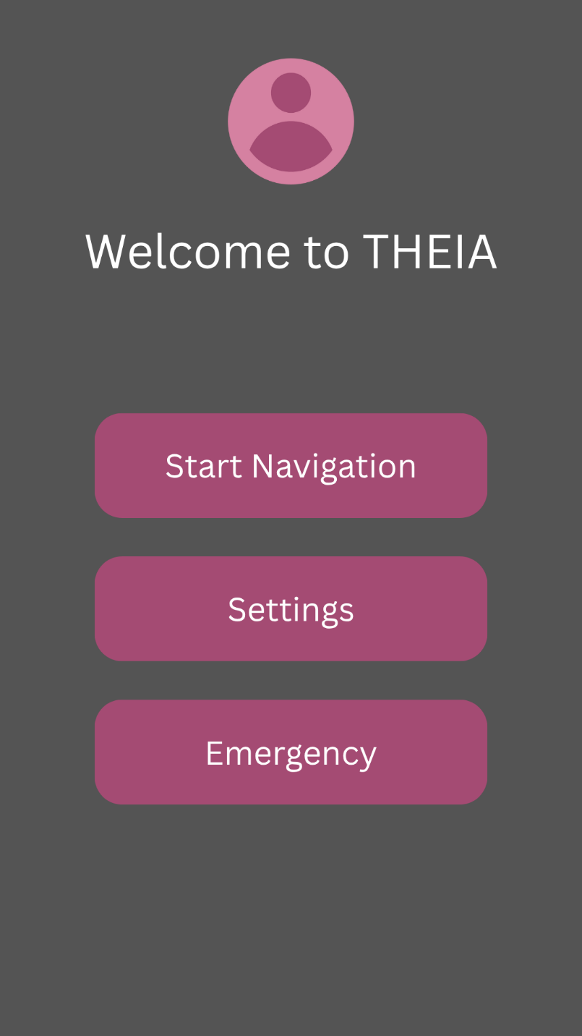

THEIA Input Navigation
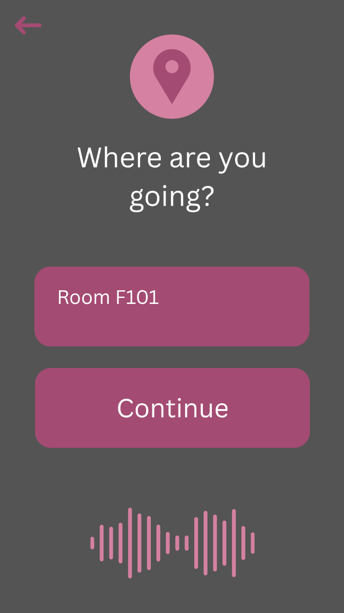

THEIA Navigation
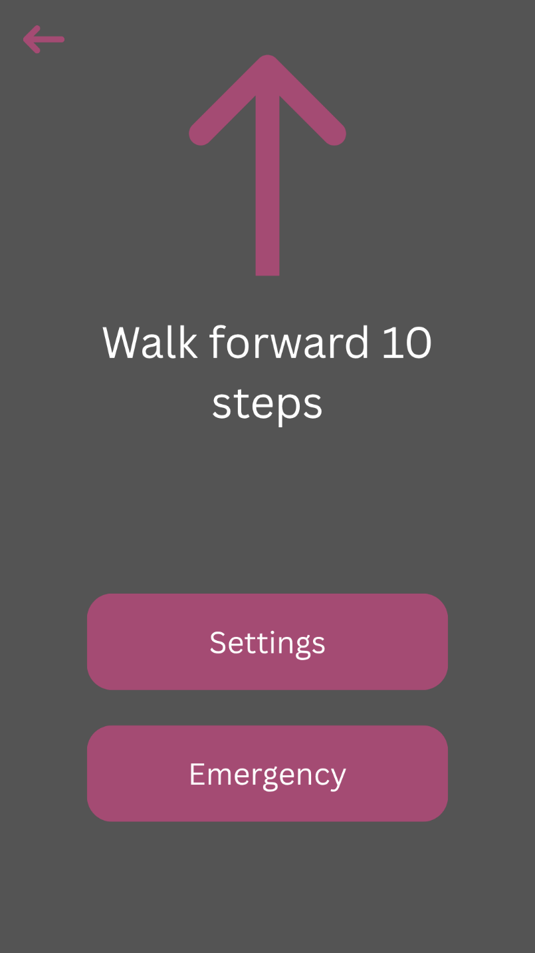

THEIA Emergency
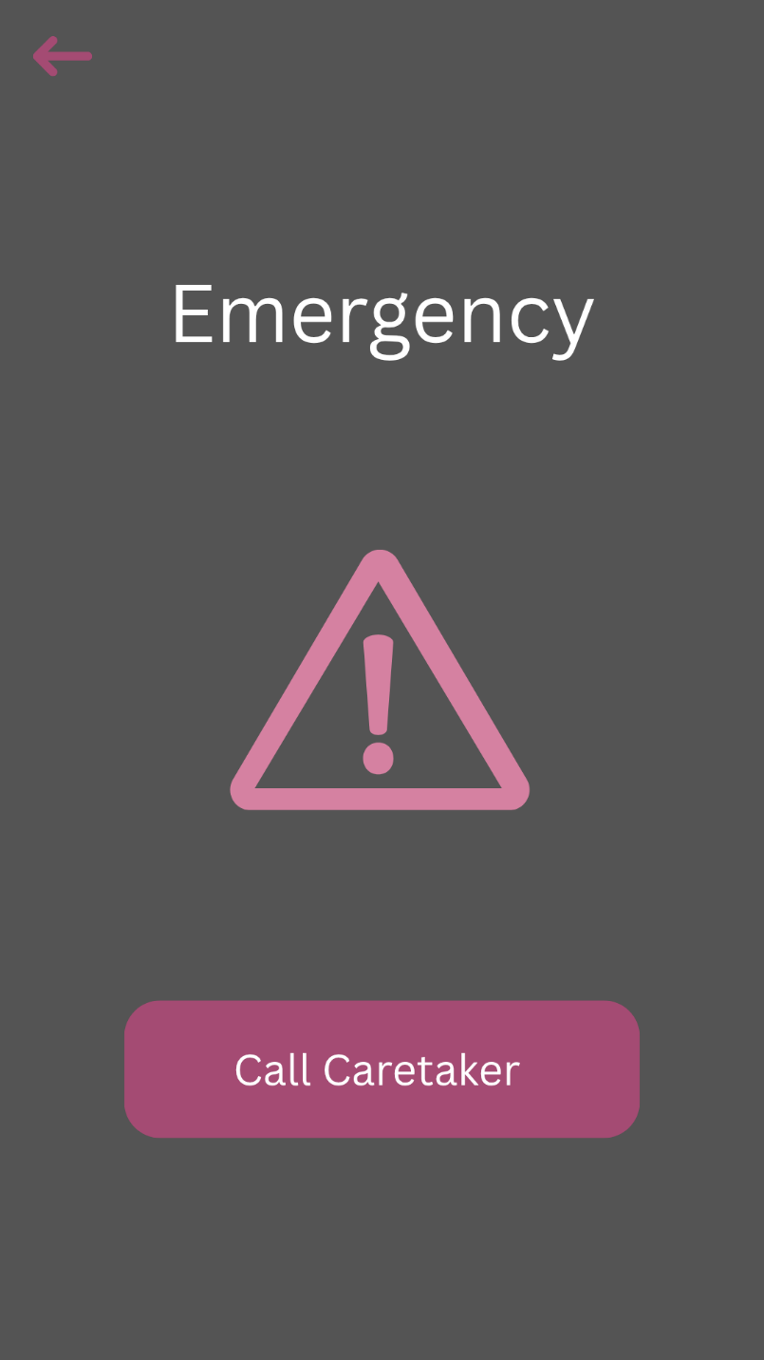

THEIA Settings
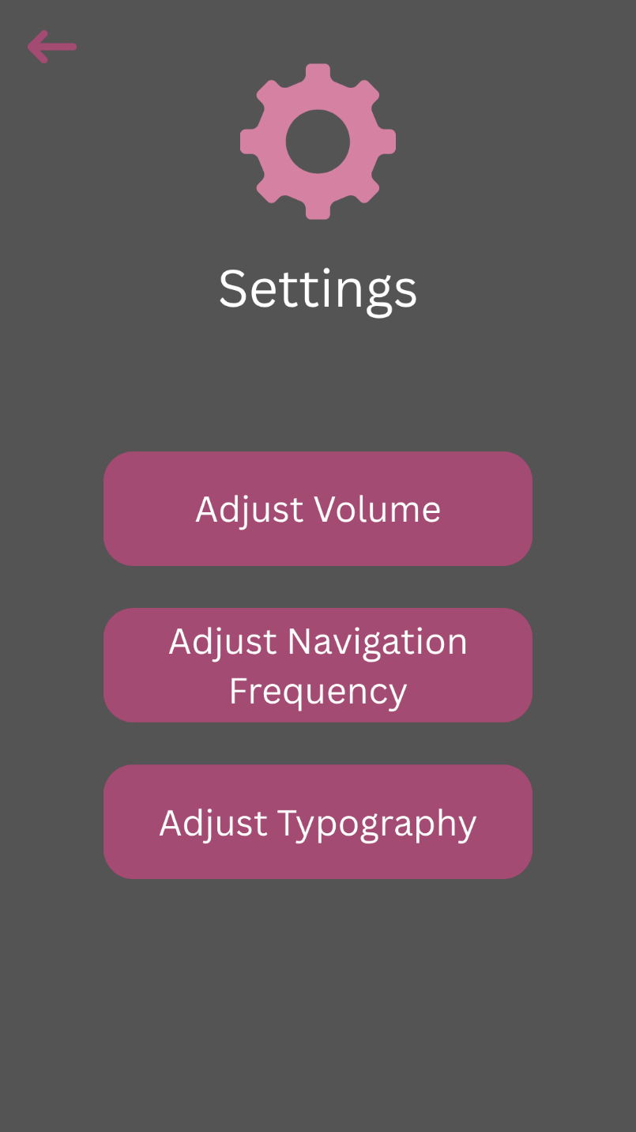

User Manual
The home screen of the app will allow the user to select whether to go to navigation, settings, or emergency response. The navigation option will prompt the user for their next location and allow the user to either type the location or speak it. The app will then show the number of steps until they have to turn, as well as speak it. Once the user has made it to their destination, the app will return to the home screen. The settings option allows the user or caretaker to tailor the app towards the user. This includes increased vocal navigation for those who need it. The emergency option will ask the user if they are ok, and if there is no response within 15 seconds, the caretaker will automatically be called.

Traceability

Functional
Functional Requirement | Functional Objective | Goals | Problem | Stakeholder
PFR1 | IFRO1 | G1, G11 | P1, P11 | Visually impaired user
PFR2 | IFRO2,  IFRO8 | G2, G8, G12 | P2, G8, P12 | Visually impaired user
PFR3 | IFRO3 | G1, G3 | P1, P3 | Visually impaired user
PFR4 | IFRO4 | G4, G11, G12 | P4, P11, P12 | Visually impaired user
PFR5 | IFRO5 | G5 | P5 | Visually impaired user
PFR6 | IFRO6 | G6 | P6 | Visually impaired user
PFR7 | IFRO7 | G7 | P7 | Visually impaired user, Emergency responder, Caretaker
PFR8 | IFRO8 | G8 | P8 | Visually impaired user
PFR9 | IFRO9 | G9 | P9 | Visually impaired user, Caretaker
PFR10 | IFRO10 | G10 | P10 | Visually impaired user, Caretaker

Non-Functional
Non-functinonal Requirement | Non-Functional Objective | Goals | Problem | Stakeholder
PNFR1 | INFRO1,  INFRO4,  INFRO5 | G11, G12 | P11, P12 | Visually impaired user, Developer
PNFR2 | INFRO3,  INFRO4,  INFRO5 | G1, G11, G12 | P1, P11, P12 | Visually impaired user, Caretaker, Developer
PNFR3 | INFRO2,  INFRO3 | G1, G12 | P1, P12 | Visually impaired user, Caretaker
PNFR4 | INFRO2,  INFRO5 | G11, G12 | P11, P12 | Visually impaired user
PNFR5 | INFRO4 | G12 | P12 | Visually impaired user, Caretaker, Emergency responder, Developer
PNFR6 | INFRO1,  INFRO5 | G11 | P11 | Visually impaired user, Developer
PNFR7 | INFRO3 | G1 | P1 | Visually impaired user
PNFR8 | INFRO2,  INFRO4 | G12 | P12 | Visually impaired user
PNFR9 | INFRO3 | G1 | P1 | Visually impaired user
PNFR10 | INFRO3 | G1 | P1 | Visually impaired user, Caretaker, Developer

Appendix I: Process Details

Meetings
Meeting Date | Topic of Discussion
9/3/2025 | Introduction call, devised roles for every team member, mutually created a set of rules that everyone will follow, started working on the prelim plan document
9/10/2025 | Checkup on Prelim plan and everyone's status on assigned work, discussed any questions/ concerns that arose while working on the document
9/17/2025 | Discussed the plan of action for the WRS document, went over slides/ video from class to ensure complete understanding
9/23/2025 | Discussed problems detailing the Prelim plan with the professor, met shortly after as a group to discuss updates on the WRS and any questions or concerns
10/7/2025 | Discussed the video slides for the presentation, went over remaining work that needed to be completed and revised for the WRS document, updated completion dates

[10]References
We do not currently have any references.

